CREATE TABLE Books (

book_id NUMBER PRIMARY KEY,

title VARCHAR2(100),

author VARCHAR2(100),

publication_date DATE

);

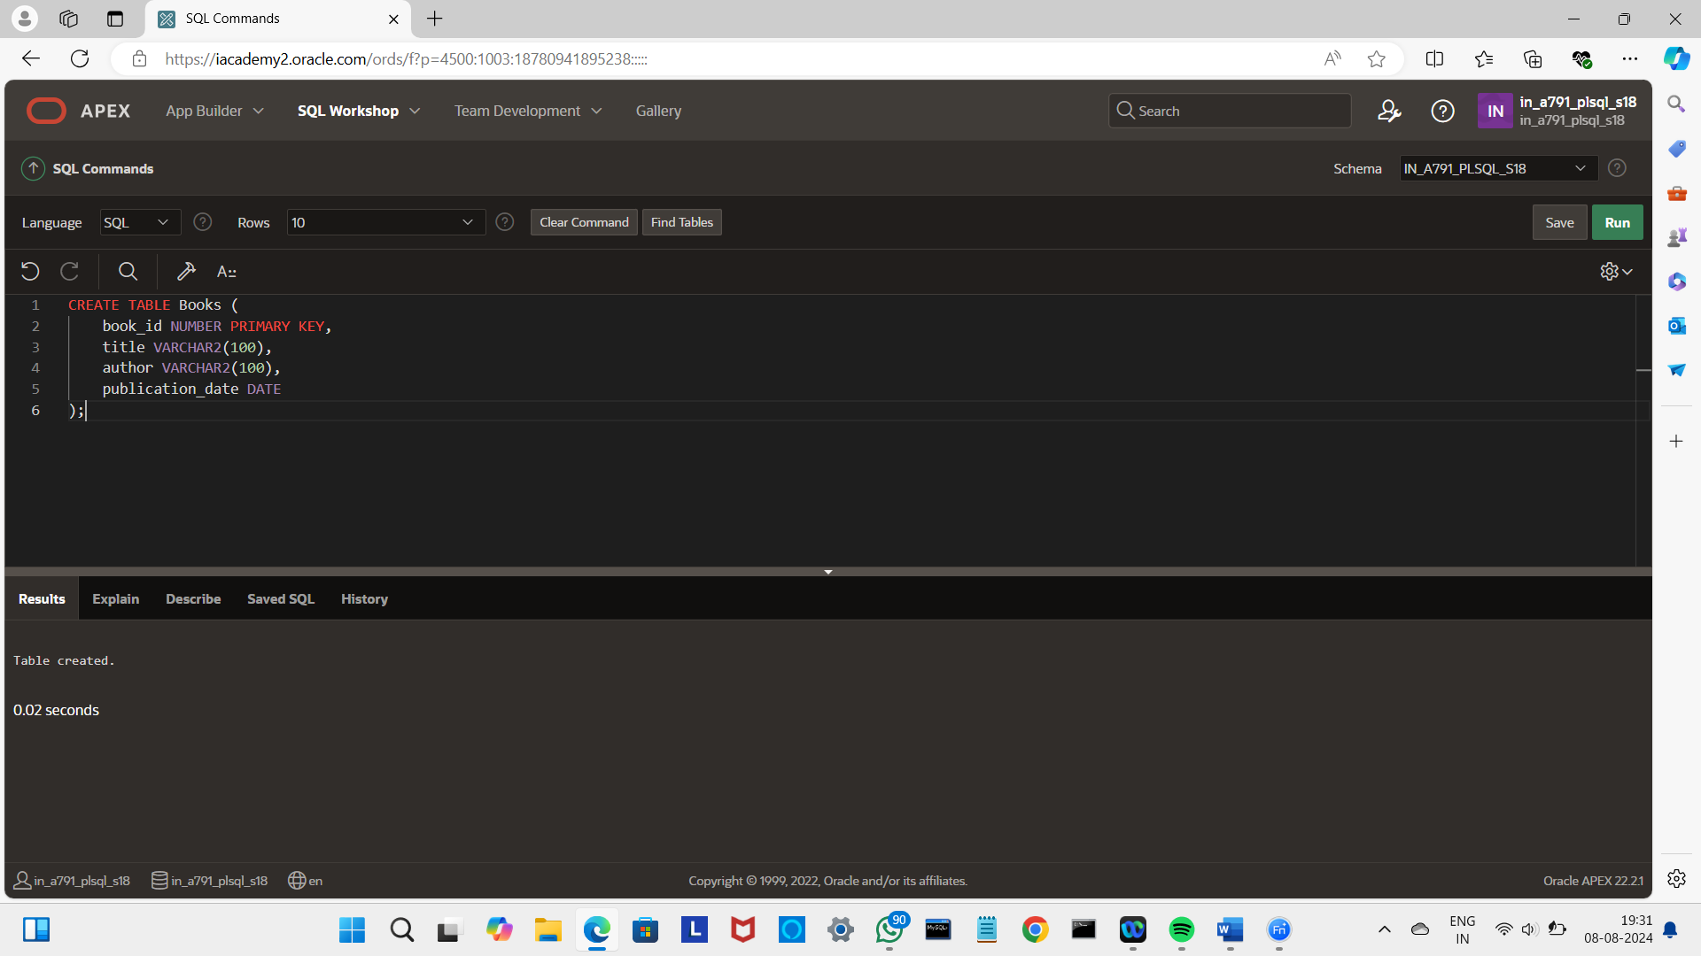

INSERT INTO Books (book_id, title, author, publication_date)

VALUES (1, 'To Kill a Mockingbird', 'Harper Lee', TO_DATE('1960-07-11', 'YYYY-MM-DD'))

INSERT INTO Books (book_id, title, author, publication_date)

VALUES (2, '1984', 'George Orwell', TO_DATE('1949-06-08', 'YYYY-MM-DD'));

INSERT INTO Books (book_id, title, author, publication_date)

VALUES (3, 'The Great Gatsby', 'F. Scott Fitzgerald', TO_DATE('1925-04-10', 'YYYY-MM-DD'));

INSERT INTO Books (book_id, title, author, publication_date)

VALUES (4, 'The Catcher in the Rye', 'J.D. Salinger', TO_DATE('1951-07-16', 'YYYY-MM-DD'));

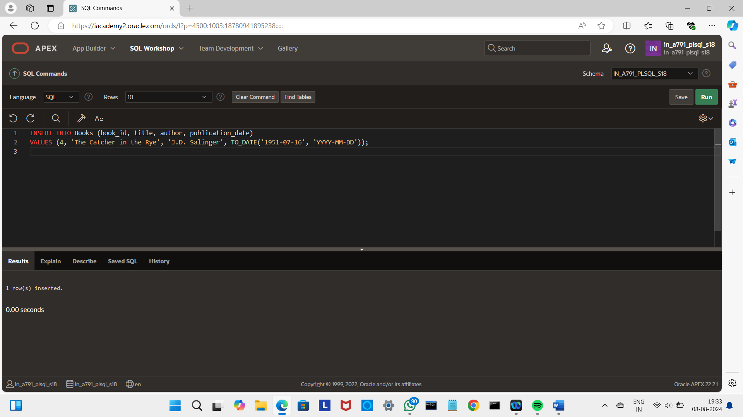

CREATE TABLE Borrowing_Details (

borrowing_id NUMBER PRIMARY KEY,

book_id NUMBER REFERENCES Books(book_id),

borrower_name VARCHAR2(100),

borrow_date DATE,

due_date DATE,

return_date DATE

);

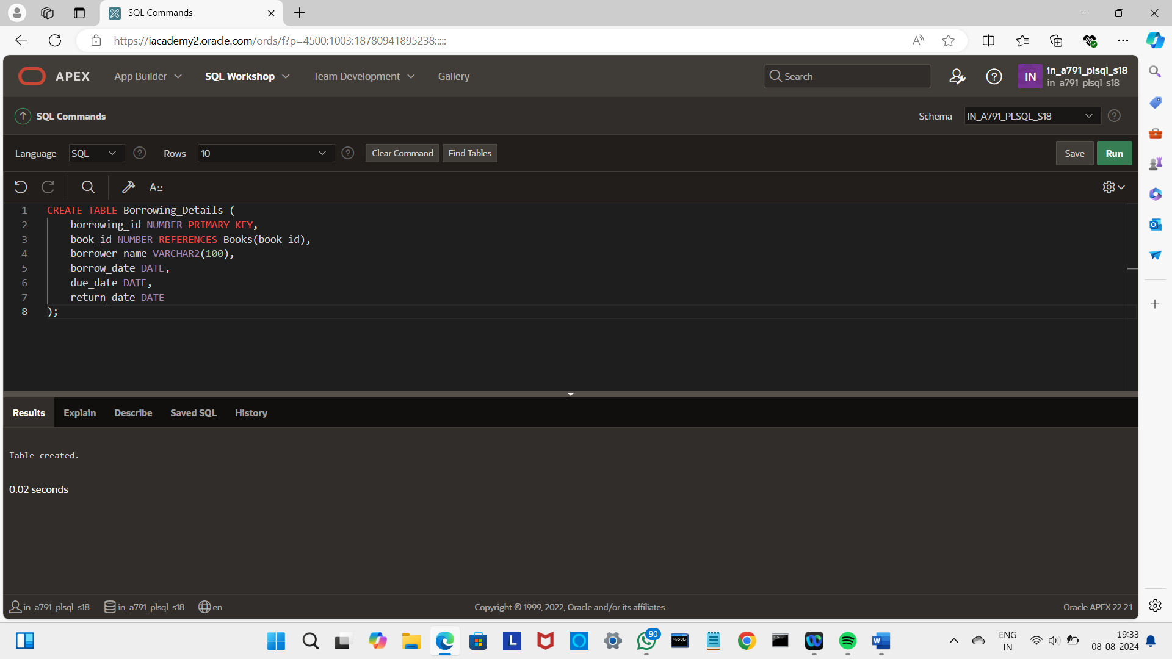

INSERT INTO Borrowing_Details (borrowing_id, book_id, borrower_name, borrow_date, due_date, return_date) VALUES (1, 1, 'Alice Johnson', TO_DATE('2024-07-01', 'YYYY-MM-DD'), TO_DATE('2024-07-15', 'YYYY-MM-DD'), NULL);

INSERT INTO Borrowing_Details (borrowing_id, book_id, borrower_name, borrow_date, due_date, return_date) VALUES (2, 2, 'Bob Smith', TO_DATE('2024-06-20', 'YYYY-MM-DD'), TO_DATE('2024-07-20', 'YYYY-MM-DD'), NULL);

INSERT INTO Borrowing_Details (borrowing_id, book_id, borrower_name, borrow_date, due_date, return_date) VALUES (3, 3, 'Carol White', TO_DATE('2024-06-30', 'YYYY-MM-DD'), TO_DATE('2024-07-30', 'YYYY-MM-DD'), TO_DATE('2024-07-25', 'YYYY-MM-DD'));

INSERT INTO Borrowing_Details (borrowing_id, book_id, borrower_name, borrow_date, due_date, return_date) VALUES (4, 4, 'David Brown', TO_DATE('2024-07-05', 'YYYY-MM-DD'), TO_DATE('2024-08-05', 'YYYY-MM-DD'), NULL);

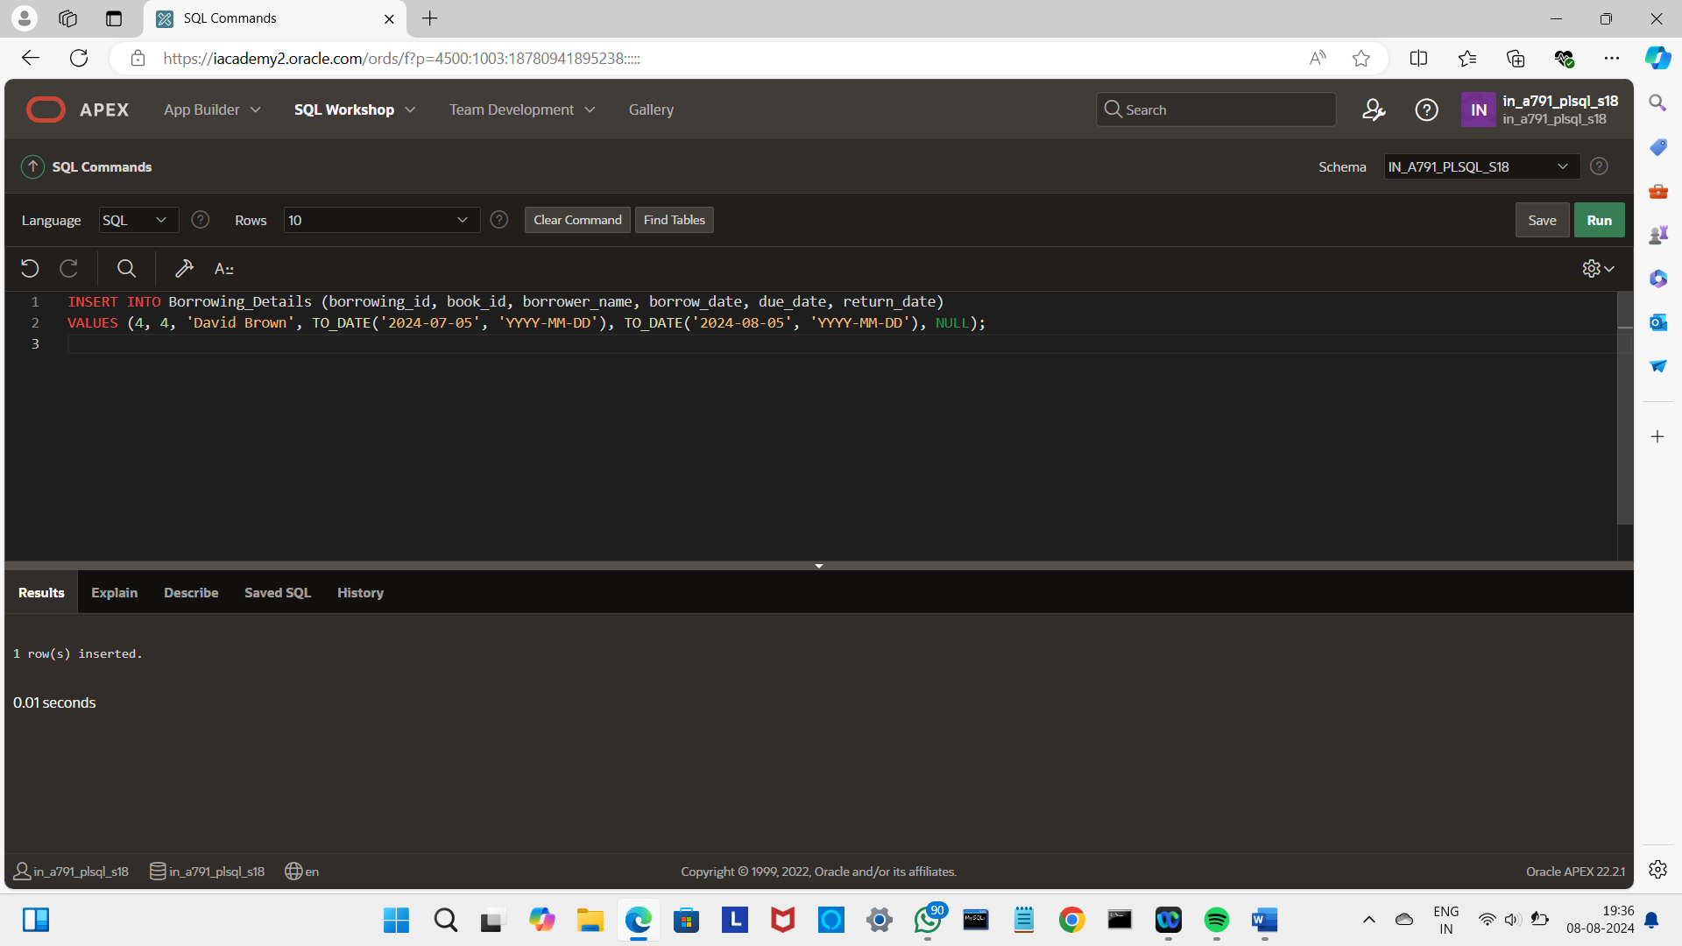

CREATE OR REPLACE PROCEDURE days_left_to_return (

p_book_id IN NUMBER,

p_days_left OUT NUMBER

) AS

v_due_date DATE;

v_return_date DATE;

BEGIN

SELECT due_date, return_date

INTO v_due_date, v_return_date

FROM Borrowing_Details

WHERE book_id = p_book_id

AND return_date IS NULL;

IF v_due_date IS NOT NULL THEN

p_days_left := v_due_date - SYSDATE;

ELSE

p_days_left := NULL;

END IF;

EXCEPTION

WHEN NO_DATA_FOUND THEN

p_days_left := NULL;

END;

/

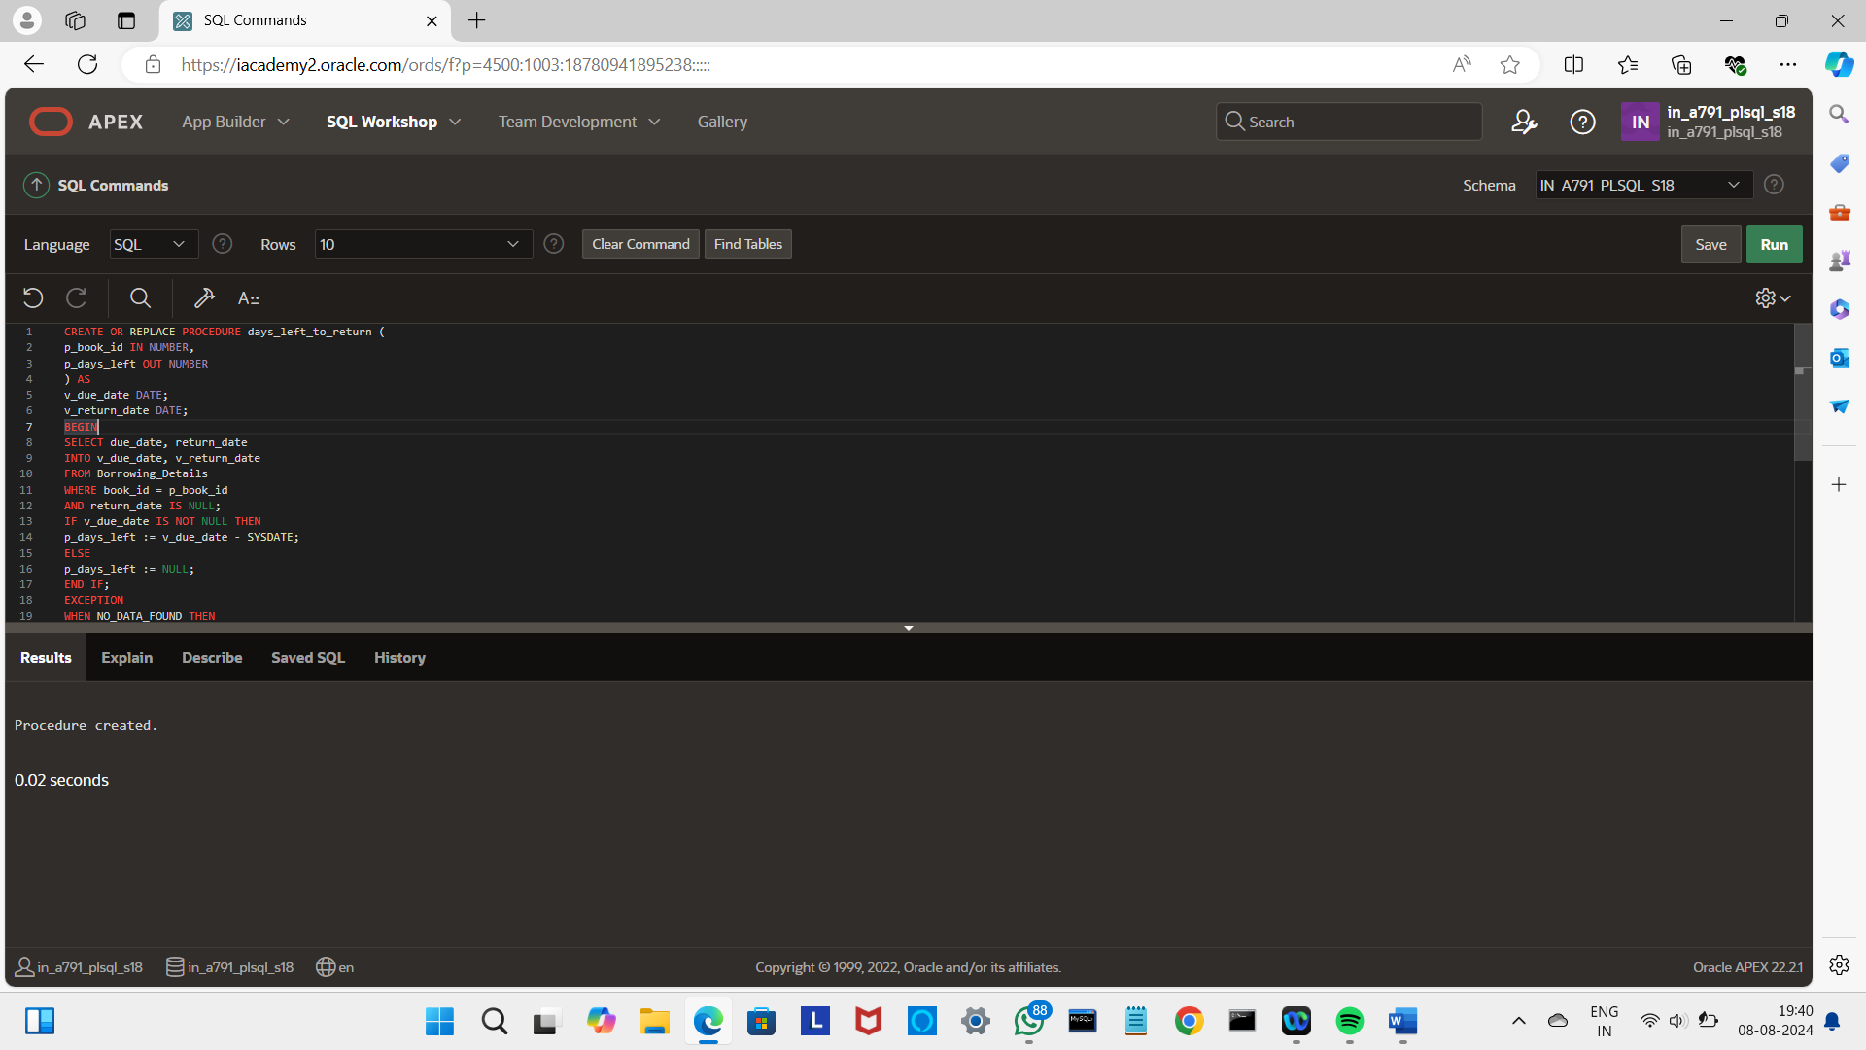

DECLARE

days_left NUMBER;

BEGIN

days_left_to_return(1, days_left);

IF days_left IS NOT NULL THEN

DBMS_OUTPUT.PUT_LINE('Days Left to Return: ' || days_left);

ELSE

DBMS_OUTPUT.PUT_LINE('Book not found or already returned');

END IF;

END;

/

